Digital Logic Design Laboratory

Lab 4

Multiplexers

Full name: Phan Tiến Đạt

Student number: EEACIU22170

Class: ……………………………………………….......

Date: …………………………………………………....

# I. Objectives

In this laboratory, students will study:

- Understand and design a multiplexer.

- Use a multiplexer and designimplement a circuit based on a function definition.

- Design combinational circuits using MUX.

# II. Procedure

1. Design multiplexer using logic gates

a. Design 2-to-1 multiplexer using logic gates:

A 2-to-1 multiplexer has I0 and I1 are the two inputs, S is the selector input, and Y is the output. When S = 0 then Y = I0 but when S = 1 then Y = I1. The Figure 1 shows the illustration of MUX 2-1.

MUX 2- 1

I0

I1

S

Y

Figure 1. The illustration of MUX 2-1.

Built the truth table:

|  |  |  |  |
| --- | --- | --- | --- |
| Input | | | Output |
| S­ | I0 | I1 | Y |
| 0 | 0 | 0 | 0 |
| 0 | 0 | 1 | 0 |
| 0 | 1 | 0 | 1 |
| 0 | 1 | 1 | 1 |
| 1 | 0 | 0 | 0 |
| 1 | 0 | 1 | 1 |
| 1 | 1 | 0 | 0 |
| 1 | 1 | 1 | 1 |

The expressions:



|  |  |  |
| --- | --- | --- |
|  | 0 | 1 |
| 00 | 0 | 0 |
| 01 | 1 | 1 |
| 11 | 0 | 1 |
| 10 | 0 | 1 |

$$\overline{S}I_{0}+I_{0}I_{1}+SI_{1}$$

Implement the circuit via simulation software and paste the result in here

Make comment on the results

The truth table provided corresponds to a 2-to-1 multiplexer (MUX) with select input ( S ) and data inputs ( I0 ) and ( I1 ). When( S ) is 0, the output ( Y ) follows ( I0 ), and when ( S ) is 1, the output ( Y ) follows ( I1 ). This behavior demonstrates how the MUX routes one of the two input signals to the output based on the select signal.

b. Design 4-to-1 MUX using logic gates.

Build the circuit. The inputs S0, S1, I0, I1, I2, I3 are driven by 6 switches.

|  |  |  |
| --- | --- | --- |
| Input | | Output |
| S0­ | S1 | Y |
| 0 | 0 | I0 |
| 0 | 1 | I1 |
| 1 | 0 | I2 |
| 1 | 1 | I3 |

The expressions:

S0’S1’I0 + S0’S1I1 + S0S1’I2 + S0S1I3

Implement the circuit via simulation software and paste the result in here

Make comment on the results

The truth table provided corresponds to a 4-to-1 multiplexer (MUX) with select inputs ( S0 ) and ( S1 ) and data inputs ( I0, I1, I2, ) and ( I3 ). The output ( Y ) selects one of the four data inputs based on the binary combination of ( S0 ) and ( S1 ). This MUX configuration enables versatile data routing capabilities, essential for selecting among multiple inputs using control signals.

c. Design 4-to-1 MUX using 3 MUX 2-1.

Implement the circuit via simulation software and paste the result in here

Make comment on the results

Using three 2-to-1 multiplexers to construct a 4-to-1 multiplexer is a practical approach that effectively combines smaller components to achieve a larger function. This method optimizes both design and resources by leveraging the inherent selection capabilities of 2-to-1 MUXs, demonstrating modular and scalable design in digital circuitry. Additionally, this setup provides flexibility in routing multiple data inputs to a single output based on control signals, which is crucial for various applications in digital systems.

2. Investigate IC 8-to-1 Multiplexer (74HC151)

Construct the circuit as below:

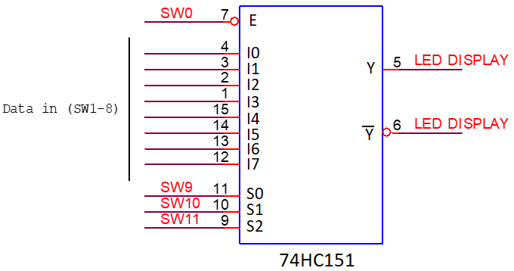

Figure 2. IC 8-to-1 Multiplexer (74HC151)

- 2 outputs are connected by using LEDs.

- The inputs are controlled by switches.

- Observe the results and fulfill the truth table

|  |  |  |  |  |  |
| --- | --- | --- | --- | --- | --- |
| INPUT | | | | OUTPUT | |
| S2 | S1 | S0 | E | Y | $$\overline{\text{Y}}$$ |
| X | X | X | 1 | 1 | 0 |
| 0 | 0 | 0 | 0 | $$I_{0}$$ | $${\overline{I}}_{0}$$ |
| 0 | 0 | 1 | 0 | $$I_{1}$$ | $${\overline{I}}_{1}$$ |
| 0 | 1 | 0 | 0 | $$I_{2}$$ | $${\overline{I}}_{2}$$ |
| 0 | 1 | 1 | 0 | $$I_{3}$$ | $${\overline{I}}_{3}$$ |
| 1 | 0 | 0 | 0 | $$I_{4}$$ | $${\overline{I}}_{4}$$ |
| 1 | 0 | 1 | 0 | $$I_{5}$$ | $${\overline{I}}_{5}$$ |
| 1 | 1 | 0 | 0 | $$I_{6}$$ | $${\overline{I}}_{6}$$ |
| 1 | 1 | 1 | 0 | $$I_{7}$$ | $${\overline{I}}_{7}$$ |

Implement the circuit via simulation software and paste the result in here

Briefly describe the operation of the IC

When, E=1, the output is always 1, regardless of the values of, S2,S1, and S0. This condition suggests that the output is constantly driven to 1 whenever 𝐸 = 1, E=1, independent of any other inputs. Conversely, when E=0, the output depends on the values of 𝑆2 , 𝑆1 , S2,S1, and S0. These select inputs determine which of the data inputs I0,I1,I2, or I3 is passed through to the output Y. For instance, if S2,S1,S0=001, the output 𝑌 Y corresponds to I1, indicating that the second data input is selected based on the control signals. This functionality demonstrates the multiplexer's ability to route specific data inputs to the output based on the binary combination of select inputs.

3. Implement the 3-variable logic function using 74HC151

- Implement Boolean expression using IC 74HC151.

- The data inputs S0, S1, S2 are connected to switches.

- Implement the circuit and verify the truth table

a. $f\left(S_{2},S_{1},S_{0}\right)= \sum_{S_{2}S_{1}S_{0}}^{ }{\left(1,3,5,6\right)}=I_{3}+I_{6}+I_{1}+I_{5}$

Implement the circuit via simulation software and paste the result in here

Make comment on the results

The Boolean function 𝑓 ( 𝑆 2 , 𝑆 1 , 𝑆 0 ) = ∑ ( 1 , 3 , 5 , 6 ) represents the logical OR of the minterms 𝑚1 , 𝑚3 , 𝑚5, and 𝑚 6 ​ . This function can be implemented using a 4-to-1 multiplexer where: I 3 , I 6 ​ , I1 ​ , and 𝐼5 ​ are connected to the data inputs based on the select lines 𝑆 2 , 𝑆 1 , 𝑆 0. The output 𝑌 Y of the multiplexer will produce 𝑓 ( 𝑆 2 , 𝑆 1 , 𝑆 0 ) based on the input configuration. This approach is efficient for implementing logical functions in digital circuits, providing a compact and straightforward method to realize complex Boolean expressions using multiplexers.

b. $f(S_{2},S_{1},S_{0}) = \sum_{S_{2}S_{1}S_{0}}^{ }{(2,3,4,7)}$

Implement the circuit via simulation software and paste the result in here

Make comment on the results

The Boolean function 𝑓(𝑆2,𝑆1,𝑆0)=∑(2,3,4,7) specifies that the output is high when the select inputs 𝑆2𝑆1𝑆0 are equal to 010, 011, 100, or 111. This function can be efficiently implemented using a 4-to-1 multiplexer, where the data inputs 𝐼2,𝐼3,𝐼4, ​, and 𝐼7​ are connected and selected based on the select lines 𝑆2,𝑆1,𝑆0

4. Implement the 4-variable logic function using 74

a. Implement the connected diagram using 74HC151.

Construct the circuit as Figure 3:

Change the logic levels of the inputs C, B, A.

Observe and make comment on the results.

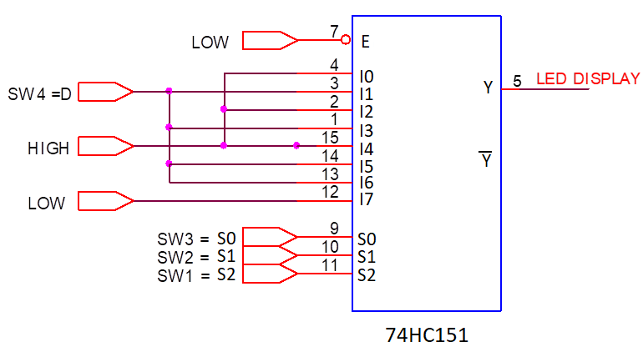

Implement the circuit via simulation software and paste the result in here

Write down the expression of $f(D,S_{2},S_{1},S_{0})$ and make comments on the results

$$f\left(D,S_{2},S_{1},S_{0}\right)=I_{0}+I_{2}+I_{4}+DI_{1}+DI_{3}+DI_{5}+DI_{6}$$

b. Implement logic expression using 74HC151

Given the expression:

$$f\left(D,S_{2},S_{1},S_{0}\right)=D S_{2} \overline{S_{1}} S_{0}+S_{2} S_{1} \overline{S_{0}}+\overline{S_{2}} S_{1} S_{0}+\overline{D}\overline{S_{2}} \overline{S_{1}}S_{0}$$

$$=D101+110+011+\overline{D}001$$

$$=DI_{5}+I_{6}+I_{3}+\overline{D}I_{1}$$

Draw the block diagram

Implement the circuit via simulation software and paste the result in here

Make comments on the results

The Boolean function 𝑓 ( 𝑆 2 , 𝑆 1 , 𝑆 0 ) = $DI_{5}+I_{6}+I_{3}+\overline{D}I_{1}$ f(S 2 ​ ,S 1 ​ ,S 0 ​ )= $DI_{5}+I_{6}+I_{3}+\overline{D}I_{1}$ ​ dictates that the output is determined by the variables 𝐼5 , 𝐼6 , 𝐼3, and the complement of 𝐷 D multiplied by 𝐼 1 I 1 ​ . This function can be implemented using a 4-to-1 multiplexer, where the data inputs 𝐼 5 , 𝐼 6 , 𝐼 3 , and $\overline{D}I_{1}$ ​ are connected to the multiplexer's inputs. The output 𝑌 Y of the multiplexer will reflect the result of the Boolean function based on the select lines 𝑆2 , 𝑆1 , 𝑆0, demonstrating the versatility of multiplexers in implementing complex logic expressions in digital circuits.